BORYS GRINCHENKO KYIV UNIVERSITY
Institute of Philology
Linguistics and Translation Department

EU BINDING AND NON-BINDING LEGISLATIVE ACTS:
LANGUAGE USE PECULIARITIES
MA Paper
Yuliia Ivanchenko
Group FAM-1-20-2.0d

Research supervisor
PhD Linguist
E. Paliichuk

Approved for defence
By Linguistics and
Translation Department
25, May, 2022, Minutes 11
____________Valentyna YAKUBA

Kyiv 2022

INTRODUCTION

In the process of translating documents, translators face the challenge: to be able to distinguish the linguistic features inherent in this area and interpret them professionally.
The last few decades have seen a growing trend toward the Ukrainian endeavour to be a member of the European Union. Ukrainian integration into Europe is the rapprochement of Ukraine with the European Union both at the level of laws and at the level of rules and customs that exist in society. Its goal is Ukraine's accession to the EU.
European integration is a foreign policy course that should create domestic demand for reforms, and public pressure on institutions that must and can implement important changes in the country.
Shortly Ukraine's possible accession to the EU is a matter of perspective, which depends on many factors. In particular, both the effectiveness of internal reforms and the transformation processes within the EU.
Thus, Ukraine on the European integration path is expected to work daily on the implementation of the Association Agreement, which moves the country on the path to the EU. However, and most importantly, today there is reason to believe that Ukraine has passed the stage of choosing between European and Eurasian vectors of state development.
Moreover, Ukraine gains to get into the international market and this is one more reason why nowadays Ukrainians have more contact with the EU or other countries.
As of today, there are many tasks, among them - the availability of high-quality Ukrainian translation of EU documents at the national level. Therefore, it is important to pay attention to the translation challenges that arise during translation.
Over the last few years, a large number of certified translations have been made with the support of EU technical projects. However, the issue of philological research on the peculiarities of the EU language, in particular Eurolect, remains relevant.
All types of EU documents are somewhat different in certain respects but they have a clear structure. They have: an introduction and final part, these documents are divided into parts, subsections, articles, etc. Legal documents are characterized by specific vocabulary.
This type of document is characterized by a large number of professional terminology, official jargon, and certain language cliché. These linguistic phenomena are known as eurolect, and it is partly artificial. As it was already mentioned, this special lect is peculiar only to the European Union documents and has their features and abbreviations. The Eurolect is important for a wide range of actions that happen in the European Union.
To study features, terminology, and phenomena, the following research papers should be studied. First of all, Daria Kasyanenko wrote in her abstract to the dissertation “Peculiarities of translation and lexical harmonization of EU legislative acts in the context of Ukraine’s European integration” studied more precious the style of English language in EU acts, paying attention to the concept of Eurolect (Kasianenko, 2011).
The European Parliament resolution of 24 March 2009 on Multilingualism has mentioned the importance of multilingualism and the importance of translation “Considers that Europe's linguistic diversity constitutes a major cultural asset and it would be wrong for the European Union to restrict itself to a single main language; Recalls that the importance of multilingualism is not confined to economic and social aspects and that attention must also be paid to cultural and scientific creation and transmission and the importance of translation, both literary and technical, in the lives of citizens and for the EU's long-term development; and last but not least, the role played by languages in shaping and strengthening identity. Stresses the vital importance of creating specific programs to support translation and of setting up multilingual terminology database networks” (European Parliament, Multilingualism, 2009).
According to the few paragraphs, it is obvious that the European Union is strongly aware of the differences between countries' languages and difficulties while translating. That is why they create a huge amount of projects which want to help translators to make a proper translation of EU documents into other countries' languages.
The last chosen paragraph of this resolution was written about creating specific programs to support translation and creating terminology database networks. Nowadays Ukraine has just an association but if our country will follow all instructions for European integration, Ukrainian translators will also face these problems and chances or have already faced them.
Many documents such as regulations or directives are not written by native speakers, such as English, but even after the version is translated, the versions in different languages are equal.
It is necessary to distinguish between the meanings for effective and efficient translation, which determines the transposition of EU legislation into Ukrainian legislation.
According to one of the requirements of the association, the legislation must take root, so translators need to work on this topic in more detail to avoid mistakes. If the document is translated incorrectly, it will have consequences, such as violation of the law and improper implementation of agreements.
The relevance of the study is predetermined by the necessity to take into account the verbal peculiarities of the EU legal acts in the process of translation into Ukrainian, which is important for the proper transposition of EU legal acts into Ukrainian legislation.
Translators who specialize in the legal field and human rights, or are just learning how to make a proper translation, need to understand exactly the features of English in EU acts, such as directives, decisions, regulations, etc.
The European Union institutions, such as the European Parliament and European Commission, have developed special requirements for the language legislation. The most important and difficult task for lawyers and after for translators is the use of standardized terms to denote special concepts of the EU, and the rejection of non-professional jargon and expressions in Latin, which are used figuratively. This knowledge is fast becoming a key instrument in translation.
The analysis of the language material enables us to reveal the basic stylistic parameters of translation of EU texts to raise awareness of EU legal discourse style among institutional translators in Ukraine.
The subject of this research is verbal means peculiar to EU binding and non-binding legal acts.
The material includes 40 EU binding and non-binding legal acts (secondary/soft law) representing immigration issues. The question of immigration remains open in many countries, especially across Europe. The EU Member States try to regulate this issue by implementing new restrictions for migrants or, conversely, by giving them more rights. Therefore, the object of this study is the verbal means of representing immigration problems in EU legal documents.
Many factors influence the EU's migration policy. Firstly, external factors such as military conflicts, as well as the demographic situation in European countries.
Mobility within the EU has also been affected by an increase in the number of member states and common needs of the labor market. Nowadays a lot of immigrants live in Germany, France, Spain, and Italy.
Regulations and decisions are increasingly important in the political life of the European Union. They are usually aimed at addressing current issues, such as the financing of immediate measures to address current migration issues, the influx of refugees, or the establishment of restrictions on the interaction between information systems in the field of borders and visas.
Nowadays, there is a need in developing new legislation regulating the issues of Ukrainian citizens on the borders of European countries due to the war.
However, we predict the low level of awareness of specific features of Eurolect among Ukrainian students, in particular of the difference in the pragmatic value of binding and non-binding acts. Therefore, our objective is to test whether graduates of translation specialty are aware of the linguistic peculiarities of EU legal texts style. Our hypotheses are as follows:
H0 – students of the philology department are aware of verbal peculiarities of EU binding and non-binding legal acts; H1 (alternative hypothesis) – students of the philology department are not aware of verbal peculiarities of EU binding and non-binding legal acts. If the alternative hypothesis is proven, it will presuppose the justified necessity of developing specific recommendations and training for future translators to raise their awareness of the EU legal style.
To prove or refute the hypothesis, first of all, the research starts with a literature overview of the general linguistic peculiarities of EU legal discourse. Nowadays many linguists study this topic. For example, Collin Robertson, a lawyer-linguist, has written a report “A lawyer-linguist view on EU terminology”. He wrote about lawyer linguist viewpoints on terminology, EU legislative acts, and terminology, EU multilingual interpretation of terms, etc. This research gives some explanation of the peculiarities of EU legal discourse.
To prove H0 will be organized a survey with questions that are going to check students` competencies for EU Legal Translation. As S. Šarčević said, “the ideal legal translator should have: thorough knowledge of legal terminology, legal reasoning and TL and SL legal systems, the ability to solve legal problems, analyze legal texts and foresee text construal, drafting skills, basic knowledge of comparative law and methods”. Even S. Šarčević remarked that this ideal legal translator does not exist but the main purpose of this research is to check if students get this knowledge and qualities during their studies. This survey will be carried out among students of translation and general philological specialties.
To conclude, the main aim of this research is to investigate specific features of EU legal acts with a focus on semantic, stylistic, and pragmatic features of binding and non-binding acts. as well as to verify the degree of awareness of EU legal style among graduates of linguistic faculties.
Therefore, the tasks include the following procedures: 1) literature overview of general linguistic peculiarities of EU legal discourse; 2) stylistic analysis of verbal means of immigration-related legal documents; 3) revealing the verbal peculiarities and differences in binding and non-binding acts; 4)analyzing the language units of each type of secondary legislation; 5) tracing linguistic features in the framework of stylistic, semantic and functional features; 6) development of questionnaire and material for statistical analysis of the general responses of the participants of the survey; 7) carrying out a survey among students of translation and general philological specialties; 8) processing the data obtained for establishing the degree of awareness of Eurolect style among the respondents; 9) interpretation of the results.
The text-corpus method allows working with eurolect and following expressions in legal documents. The method of semantic differentiation allows distinguishing components in the meanings of words. Based on the results of a literature overview of general linguistic peculiarities of EU legal discourse the survey will be conducted.
The next step after the survey is processing the data obtained for establishing the degree of awareness of Eurolect style among the respondents and the interpretation of the results in percentage form.
One of the latest researches in this field was made by Tomáš Svoboda “Quality assurance in governmental institutions across Europe”. Moreover, he writes about Czech Republic`s experience before its EU accession. This is useful to see how another country overcame some same difficulties and to make the exchange of experts or organize seminars, traveling activities. Observation of experience of different countries can help us to conduct more accurate and important rules.
According to the results, recommendations will be chosen, willing to build young specialists’ competencies in EU translation.
The material of research was selected from the EUR-Lex, where all legal documents are published. In this research, only migration-related documents were analyzed. The total number of legal documents that were analyzed was 40.
This research and results were discussed at the conference:
1. All-Ukrainian scientific-practical online conference of students, graduate students, doctoral students and young scientists “Current issues of literary criticism and linguistics” (05.11.2020)
Also, the outcomes of the paper were published in the following source:
1. Second International Scientific and Practical Online Conference “Philological and Pedagogical Studies in 21st Century National and International Science” (2020)
General volume of the paper includes 34 pages.
The paper structure includes an introduction, 2 chapters with conclusions to them, general conclusions, a bibliography, sources of material, an appendix, and a summary.
The introduction shows the orientation of the problem, the hypothesis, the tasks of the research, and the methods.
The first chapter is dedicated to the examination of analyzing the main problem of research, literature overview of general linguistic peculiarities of EU legal discourse, and stylistic analysis of verbal means of immigration-related legal documents.
The second chapter aims to survey students of translation and general philological specialties. After processing the data obtained for establishing the degree of awareness of Eurolect style among the respondents is an interpretation of the results.
The general conclusion represents the development of recommendations and guidelines for building young specialists’ competencies in EU translation.

Theoretical background.
1.1. Functions of each EU legal document act.
In the European Union there are 27 members and 24 official languages but only 3 procedural languages: English, French, and German.
Moreover, the EU is characterized by its multiracialism. Without a doubt, languages that are used in the Member States are a fundamental element of European culture. The European Union supports it and is proud of its diversity.
It is incredibly important to know the number of official languages in the EU.
Politicians make important decisions and changes in the political system and translators should translate them. Translation of legal documents cannot be easy, so these people should be aware of differences in legal language.
When a new country just entered the EU translators have to create a new vocabulary full of eurolect and jargon.
Citizens can find legal acts and their summaries freely in all EU official languages. In addition, Commission proposals for legal acts are also available in all those languages.
However, not every document is available in all EU languages because these documents are not of general application.
The EU Commission translators and interpreters have a high level of education and have a good background in translation.
Machine translation cannot be perfect because people are still working on artificial intelligence, that is why highly skilled translators are needed.
1.2. Primary and secondary law
European Union law has the binding force and is available in all official EU languages. Every action the EU takes is based on treaties. Treaties are binding agreements and they set out the objectives of the EU. They have information about the institutions' work, decisions, and relationships between members and the organization (3).
Furthermore, it is crucial to be aware of the principles of uniform application of EU law. EU law which, after its entering into force, becomes part of the internal legal orders of the Member States, must be applied uniformly by the courts. Politicians can understand the effectiveness of EU law if the objectives of legal documents are achieved. The purpose of the principle is to ensure the effectiveness and coherence of the EU law system.
There are two basic sources of EU law: primary law and secondary law. Primary laws in the EU are treaties, and secondary laws are regulations, decisions, recommendations, directives, and opinions.
Primary law consists of the treaties that establish the framework of the European Union's legal order. Secondary law includes legal instruments adopted on the basis of these treaties, such as regulations, directives, decisions, and agreements. In addition, there are the general principles of EU law, the case-law of the European Court of Justice, and international law.
First of all, primary law includes treaties that member countries decide to enter into force. Moreover, these agreements have an international nature.
Secondly, it consists of general principles of functioning of the EU, created thanks to rulings of the European Court of Justice and decisions of the Council. These principles include those developed by the EU under other documents, such as the European Convention on Human Rights.
What’s more, these agreements include the founding treaties, such as the Treaty of Paris, the Treaties of Rome, and the Treaty of Maastricht. Important elements of primary law are the Treaties of Accession, which decide on the accession of individual countries to the Community.
On the contrary, secondary law is created on the basis of primary law. We can classify secondary law, also known as, derivative law, into 5 categories. The first category is directives, which are binding. They are usually addressed to the member states of the EU. The second category is regulations. These documents have one big purpose - to unify the law in the member states. The third category is decisions. They are always addressed to a defined group. Also, there are some other types of non-binding acts, which include recommendations and opinions.
1.2.1. Primary law.
Primary law has the following peculiarities: first of all, these documents are at the top of the hierarchy of EU law standards and are created on principles that were developed under public international law. Secondly, they are made by EU member states, constituting the EU, as it defines the objectives and functioning of the EU as an international organization. Thirdly, can be directed to different addresses such as different European Union institutions. Moreover, they are done according to the legal basis and have bodies and units (2).
Moreover, primary law includes not just treaties. It also includes other legal documents: acts of the Council and the European Council of a constitutional nature, general principles of law, the Charter of Fundamental Rights of the EU, and also treaties.
As well as it is important to know what primary law includes, it is necessary to know its features.
European primary law consists of the main major international agreements. They are the basis for the existence and functioning of the EU and also consist of a preamble, substantive and formal legal content, protocol (annexes), and declarations. Interpretation of the Treaties is an absolute competence of the Court of Justice of the European Union (CJEU).
Treaties have different types:
1. Foundation treaties (Treaty of Paris, Treaties of Rome);
2. Accession treaties (Treaty of Athens);
3. Treaties amending the founding and reforming treaties (Treaties of Amsterdam, Nice) (4).
1.2.2. Secondary law.
Secondary legislation is created by the EU institutions. On the basis conferred and within its framework, legal acts have different functions, features, addressees, and a different legal nature.
The binding legal instruments that are Secondary law divides into binding such as regulations, and directives and non-binding (soft laws) such as communications, opinions, and recommendations.
Directives bind in relation to the result to be achieved and they must be implemented in the national legal order. It requires a statement of reasons and publication in the EU.
Implementation of directives should be within the timeframe specified in it. It can be 3-5 years. In addition, an implementation must be effective and complete. However, lack of implementation or incomplete implementation would cause sanctions (2).
Decisions should be binding in their fullness. This type of document can be legislative and non-legislative (delegated and executive). Decisions can be addressed to institutions, offices of the EU, and individual entities. Moreover, decisions are binding just on its addressees. They can be individual and of general application.
1.2.3. Regulations and decisions.
From the perspective of law, regulation is a document that limits some aspects or areas and controls. It has plenty of meaning that can be defined as a single concept. In the law, it can be accompanied by some restrictions in order to monitor and achieve targeted goals.
Regulations and decisions are usually aimed at addressing current issues, such as the financing of immediate measures to address current migration issues, the influx of refugees, or restrictions on the interaction between information systems in the field of borders and visas. It is this pragmatic orientation of documents that determines their lexical, grammatical, and stylistic features, which is an urgent task for specialists in both general philological practice and for specialists in the field of translation.
To sum up the binding and non-binding legal instruments, first of all, the general application of the regulation is required. It is binding in its entirety and directly applicable to all members of the EU countries. Secondly, in order to achieve a goal, a directive will be obliged to bind every Member State that it is sent. The authorities will decide on the form and method of addressing, but it is left to the national authorities the choice of form and methods. Thirdly, a decision shall be valid in its entirety and this type of binding legal instrument is usually specified to someone and shall be binding only on them (5).
Moreover, opinions and recommendations have moralistic and political authority. Opinions of the EU institutions issued by the EU institutions give an assessment of situations or developments in Europe or in individual member States. Recommendations call upon the party to whom they are addressed that behave in an unusual way and not place them under any legal or criminal penalty.
1.3. Features of legislative acts of the EU Institutions.
All types of EU documents have certain features, but they are united by a clear structure. They have an introductory part and a final, the division into parts, subsections, articles, etc. Legal documents have always differed in specific vocabulary from other documents (6).
Such documents are characterized by a large number of professional terminology, clerical work, and certain language stamps.
In appendix is 1 and 2, there is the EU decision of 27 November 2019 on the mobilization of the Flexibility Instrument to fund immediate budgetary measures to address current problems of migration, refugee influx and security threats and the REGULATION (EU) of 16 April 2014 establishing the Asylum, Migration and Integration Fund.
The Flexibility Instrument is one of the special tools that allow the EU to mobilize the necessary funds to respond to unforeseen events such as crises and emergencies.
All types of EU documents have certain features, but they are united by a clear structure. They have an introductory part and a final, the division into parts, subsections, articles, etc. Legal documents have always differed in specific vocabulary from other documents. Such documents are characterized by a large number of professional terminology, clerical work, and certain language stamps (Helios J., Jedlecka W., p.56).
Translators specializing in, or just mastering, the legal field need to understand what the specifics of EU-language EU legislation are, such as directives, decisions, regulations, etc.
It is not just European politicians and lawyers who need to understand what Eurolect or Eurolect is. These are special dialects, unique to the EU, with their own peculiarities, abbreviations, and so on.
The horizontal structuring (belonging of a professional language to a certain branch) and vertical stratification of professional languages ​​(distribution of professional languages ​​into strata according to the level of their content specialization) proposed by L. Hoffmann allow us to single out the right language - the subtext of European law and mark it as a legal Eurolect (Kasianenko, p.100).
The enrichment of the Eurolect is facilitated by the enrichment of the language fund of the EU countries and lexical and semantic processes (borrowing, metaphorization, terminology).
Features of legislative acts of the EU Institutions:
- is the use of standardized terms to denote special EU concepts (Flexibility Instrument),
- rejection of jargon and Latin expressions used figuratively.
- sentences have a unique structure - example: “In order to allow for the quick use of the funds”.
- archaic words such as thereof, whereof (and other derivatives, including -at, -in, -after, -before, -with, -by, -above, -on, -upon) are used in legal English mainly, to avoid repeating names or phrases. - for example restriction of processing thereof(Kasianenko, p.86).
In addition, punctuation marks are almost never used in such acts. There was a widespread opinion among lawyers that the meaning of legal documents is contained only in the words used and their context. In modern acts, punctuation is used to clarify their meaning.
1.4.Translation challenges.
It is necessary to distinguish the importance of the functions of each document for effective translation, which leads to the transposition of European legislation into Ukrainian legislation. Legislation must become a habitual and integral part of political life.
Unfortunately, no one can predict when Ukrainian translators will get used to the EU law and rules on how to translate documents from EU institutions into Ukrainian. If the translator makes a mistake in the translation, it can have inevitable consequences. For example, a directive can be understood wrongly and implemented incorrectly. Also, it can lead to misunderstandings between politicians and can lead to economic and legal problems.
The purpose of this work is to clarify the stylistic and pragmatic features of binding and non-binding documents.
1.4.1. Linguistic interpretation in jurisprudence.
It is widely believed that interpretive activity should begin with the application of linguistic directives. Sometimes there are still cases when, in addition to chronological priority, linguistic directives are given the priority of their weight. (Zieliński, Bogucki, Choduń, Czepita, Kanarek, Municzewski, 2009).
Grammatical, linguistic, and semantic features still play a major role. On the basis of systems, legal rights related to the culture of civil law and common law even speak of the priority of linguistic interpretation and the subsidiarity of systemic and functional interpretation.
When a translator has a situation where a linguistic interpretation gives a clear and unambiguous result, the translator can rely on the result of the linguistic interpretation, but if the result of the linguistic interpretation is in doubt, then it should be called a systemic and functional interpretation. On the contrary, the translator may not be sure of the accuracy of the result of the linguistic interpretation. However, the priority of linguistic interpretation is not determined absolutely. (Helios, Jedlecka, 2009, p. 121)
Regardless of the points of view presented above, the literature emphasizes that the place of linguistic rules in interpretation is due to the fact that legal interpretation usually refers to a legal text. We are talking about some linguistic expressions, which must first be identified as corresponding to the solution of a legal problem and then reconstructed to establish the meaning of the text as a whole and the meanings of the individual components of this expression.
Thus, the role of the text as the main object of interpretation is decisive in the question of the place of linguistic rules in the process of interpretation. With rules. Linguistic prisms are concerned with interpretation.
In European Union law the use of methods of interpretation that translators use in national and international law can be different. These characteristics are different because international law and national legislation are usually based on statutory law. Nowadays there is an incredible increase in the importance of other methods of translation. (Bator, p.282-283)
Moreover, plenty of terms in the EU law do not have a fixed meaning, so when translators deal with their implementation into their native language, they can meet obstacles. The meaning can change and change in the whole legal system of the EU. In addition, the law in the EU tries to keep a balance between the different interests of member states and politicians.
The EU laws have been already implemented in many languages, so if a new member wants to implement European law, this country can have a look at their neighbour's previous experience. For example, when Ukraine is trying to implement EU law, our country can look at the experience of Poland and find some similarities or common mistakes.
The multitude of authentic languages ​​is the reason why the same legal concepts may differ in content and scope in the different Member States. It is also related to the legal culture of a particular country and how this or that concept is understood in this culture.
According to a large number of terms in the Union, there is a strong economic connotation, which cannot but influence the order for preferable methods of interpretation. At the moment, it is possible to say that a reading of EU law starts from an analysis in order to understand its text, but the norm derived from the provisions of EU law is not deciphered from them. (Kalisz, 2015 p. 201-221)
The European Union is multilingual, there is a complex language situation. It happened under the influence of different factors, for example, cultural differences, politics, geographical factors, and migration. People speak their native languages of its territory and a notable part of the EU citizens speak several languages. They are made under influence of geographical factorsMultilingualism is considered the symbol of the Union's identity. In the EU, this diversity is valued by European countries. The language of all member state members of the Union is considered an important source of cultural richness.(Gajda, 2013, p.7-29)
Unfortunately, citizens don’t talk a lot about the origins of multilingualism. One of the reasons why it happened is the following: post-war situations around the world and especially in Europe, where every effort was made to ensure that there was as little contention as possible and to reduce the feeling of disadvantage if someone speaks another language.
As a result of this, other motives and justifications for the multilingual Union are now becoming emphasized. The European Union wants to communicate with its citizens, and also for individual EU member countries as well as institutions in an official language. It is worth noting that multilingualism helps to improve the transparency, efficiency, and legitimacy of EU institutions. (Luczak, 2010).
1.5.Migration issue.
Now more than ever, the issue of migration remains open in many countries. In particular, the Member States of the European Union are trying to regulate this issue by imposing new restrictions on migrants or, conversely, by giving them more rights. In recent years, the factors that shape the EU's migration policy are, first of all, external factors, as well as the demographic situation in European countries and the needs of the labor market. Mobility within the EU has also been affected by an increase in the number of member states. Most foreigners live in Germany, France, Spain, and Italy.
Regulations and decisions are usually aimed at addressing current issues, such as the financing of immediate measures to address current migration issues, the influx of refugees, or restrictions on the interaction between information systems in the field of borders and visas. It is this pragmatic orientation of documents that determines their lexical, grammatical, and stylistic features, which is an urgent task for specialists in both general philological practice and for specialists in the field of translation.

2. Research Methods.
During the European integration of Ukraine local translators are struggling with some obstacles on how to make a proper translation of the EU legal documents. In order to achieve success in this field, translators have to cooperate with lawyers and politicians. This cooperation will help to stay away from making ill-considered mistakes that can cause conflicts or misunderstandings on the political scene.
Structural linguistic analysis
In order to check the H0 in this research was conducted an online survey. These questions helped to check students’ competencies and make an overall conclusion.
This questionnaire consists of 16 open and closed questions that participants were able to answer, using Google Forms. In order to check students’ knowledge were taken few sentences from directives, regulations, decisions and recommendations from the 100 analyzed documents for this research.
2.1. Results.
At the end of the research 32 students answered the philology, departments answered this survey which helps to check if students of the philology department are aware of verbal peculiarities of EU binding and non-binding legal acts (diagram 2.1 ). Participants noticed that they are from different Universities such as Borys Grinchenko Kyiv University, National University of Kharkiv, Zaporizhzhia National University, and Odesa II Mechnikov National University.
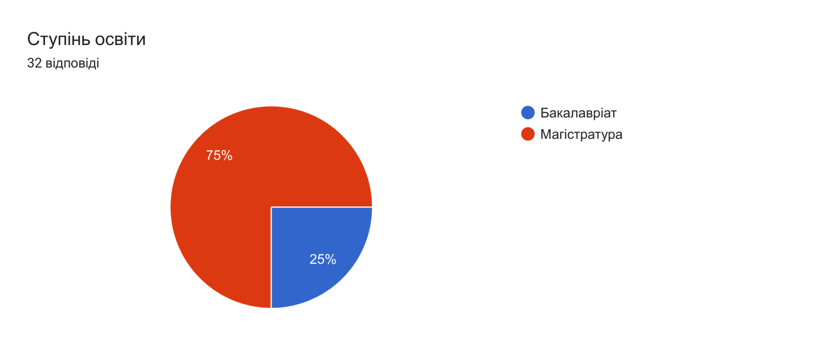
Diagram 2.1
According to this diagram, more than half (74.2 %) of participants have already finished their bachelor's degree or just studying and just 25.8% decided to study and get a master's degree.
If this hypothesis will be proven it will be obvious that Ukrainian students have enough competencies and get an excellent level of knowledge during their studies at the university. If this hypothesis will be refuted there will be just one piece of evidence that students of the philology department do not have enough knowledge to translate EU binding and non-binding documents. It means that it should be solved during the next few years because Ukraine is actively proceeding to join the EU. Students will have to improve their translator’s competencies during their studies and be ready for new challenges.
In the first part of the questionnaire are the next four questions:
1. Do you have experience in translating EU legal acts?
2. Did you study the course on translating EU legal acts?
3. Do you know the difference between primary and secondary law in the EU?
4. Do you know the difference between binding and non-binding leпal acts?
Our results found evidence that more than 80% (diagram 2.2) of participants have never had the experience in translating EU legal acts and just 6,3% had a course on translating EU legal acts. It is interesting to notice that just 2 out of 32 had a course on translating EU legal acts.
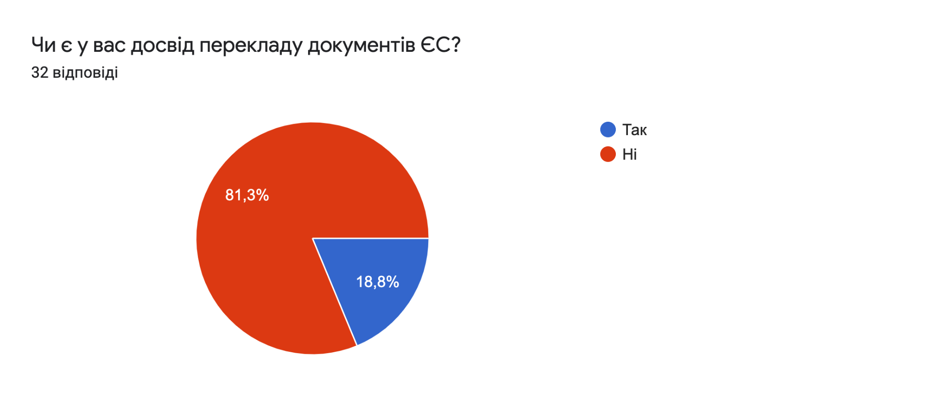
Diagram 2.2
In addition, the findings on questions number 3 and 4 are also unconvincing. Surprisingly we got the same result for these questions. From the results, it is clear that just 6 participants (18.8 %) have already heard about primary and secondary law and now the difference between binding and non-binding legal acts.
It is interesting to notice that such an important topic wasn’t taught at all at Universities and did not prepare students for their future work life.
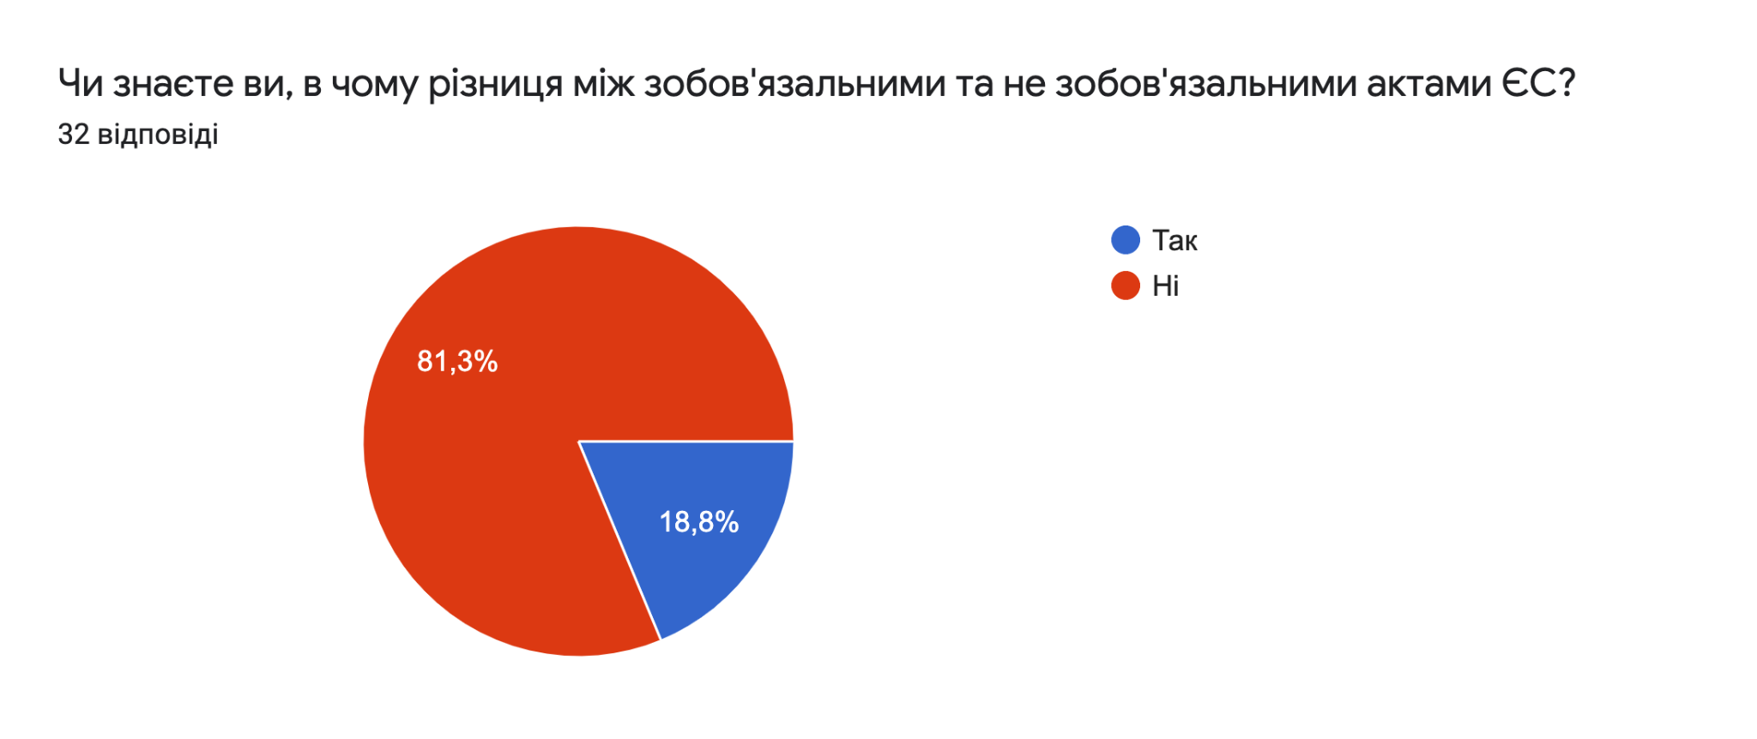
Diagram 2.3
In the next part of the questionnaire, we put a few sentences from binding (directive, regulation, decision) and non-binding (recommendation).
We put 6 questions with closed answers and 2 with open.
1.Оберіть правильний варіант перекладу з директиви: "Member States may provide applicants with a travel document" | можуть надавати  (71,9%) | повинні надавати  (25%) | мусять надавати  (3,1%)
2. Оберіть правильний варіант перекладу з регламенту: "Member States should be present or represented for visa purposes in all third countries whose nationals are subject to visa requirements" | слід бути присутнімі або представ- леними  (50%) | мають бути присутніми або представ- леними  (28,1%) | зобовязані бути присутніми  або представле- ними  (21,9%)
3. Оберіть правильний варіант перекладу з рішення: "That amount shall be used to finance measures for managing the refugee crisis." | буде використана  (34,4%) | слід використати  (34,4%) | повинна бути використана  (31,3%)
4. Оберіть правильний варіант перекладу з рекомендації: "To leverage skills, qualifications and the motivation of individuals in need of international protection, other complementary pathways for admission, such as education or work, should also be explored. " | слід також досліджувати  (56,3%) | необхідно також досліджувати  (31,3%) | можна також досліджува- ти  (12,5%)
5. Оберіть правильний варіант перекладу з висновку:"Whereas, the common outline drawn up by the Regional Policy Committee specifies what information these programmes must contain under the five chapters." | повинні містити  (56,3%) | мусять містити  (28,1%) | слід містити  (15,6%)
Table 2.1
In the questionnaire there are also two open questions with examples that we took from directives and regulations. In question number six 17,4% of students gave correct answers. Results are in diagram 2.4.
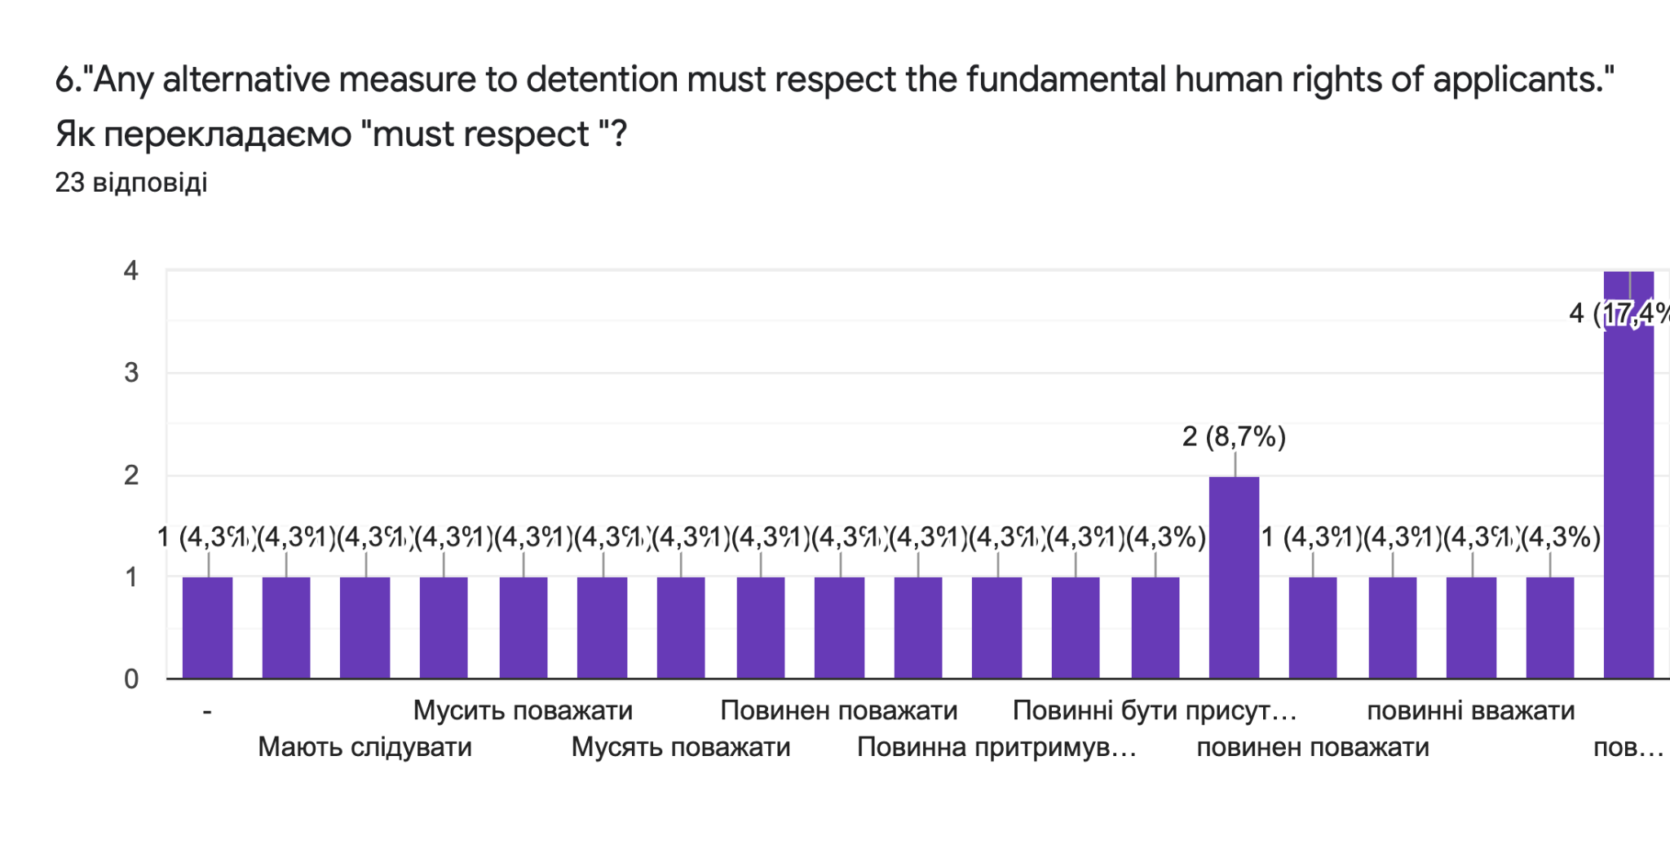
Diagram 2.4
At the end of the questionnaire were 2 questions: about difficulties and the next steps in the translation field.
In the question about difficulties, participants were able to choose more than one answer. These findings showed difficulties that students had during fulfilling this questionnaire.
3,1% | complexity of documents
25% | there were no difficulties
40,6% | insufficient level of training
53,1% | lack of translation experience documents
Table 2.2
Moreover, the results of the empirical studies showed that participants do not have enough experience and it causes problems when they need or have a chance to deal with translation EU legal documents.
However, in addition, we asked participants if they want to translate when they have deep knowledge and experience of translating EU law, which of the EU acts would you like to translate? It is interesting to note that participants wrote down the next: cooperation agreements, protection of human rights, and EU constituent documents.
Thanks to this research we were able to check students’ competencies for EU Legal Translation. After analyzing the research questionnaire we found that students know how to translate EU documents without an excellent level of knowledge and previous background in translation.
Answering open questions students gave the same answer
Moreover, students have some difficulties in translating because they cannot be sure which option to choose and as they noticed, they did not have enough practice at University or did not have it at all. Even complexity of documents does not terrify Ukrainian translators, students are disappointed because of a lack of translation experience documents.
In conclusion, it seems that H0 proved that students of the philology department are aware of the verbal peculiarities of EU binding and non-binding acts. However, we cannot say that this research should be continued. Students noticed that they lack knowledge and it should be changed because Ukrainian students will be translators after graduation and Ukrainian law needs translators with a high level of education who can implement EU law in the Ukrainian legal system and make a proper translation of important law documents.

3. Conclusions and discussion.
Each language is unique and has its own linguistic features. In the process of processing documents, a specialist in any field is faced with the task - to be able to distinguishing the linguistic features inherent in this area and professionally interpreting them.
All types of EU documents have certain features, but they are united by a clear structure. They have an introductory part and a final, the division into parts, subsections, articles, etc. Legal documents have always differed in specific vocabulary from other documents. Such documents are characterized by a large number of professional terminology, clerical work, and certain language stamps.
It is not just European politicians and lawyers who need to understand what Eurolect or Eurolect is. These are special dialects, unique to the EU, with their own peculiarities, abbreviations, and so on. Translators specializing in, or just mastering, the legal field need to understand what the specifics of EU-language EU legislation are, such as directives, decisions, regulations, etc.
The EU institutions have developed special requirements for the language of legislation. The most important thing is the use of standardized terms to denote special EU concepts, the rejection of jargon, and Latin expressions used figuratively. The enrichment of the Eurolect is facilitated by the enrichment of the language fund of the EU countries and lexical and semantic processes (borrowing, metaphors, terminology).
Now more than ever, the issue of migration remains open in many countries. In particular, the Member States of the European Union are trying to regulate this issue by imposing new restrictions on migrants or, conversely, by giving them more rights. In recent years, the factors that shape the EU's migration policy are, first of all, external factors, as well as the demographic situation in European countries and the needs of the labor market. Mobility within the EU has also been affected by an increase in the number of member states.
During the research, the hypothesis was proven that students of the philological department are aware of the verbal peculiarities of EU binding and non-binding acts. However, they noticed that they still lack knowledge in this field and think that they do not have enough practice at University.
In order to continue this research and help students, one of the main goals is the development of recommendations and guidelines for building young specialists’ competencies in EU translation.

